Group Game Design Document (GDD)

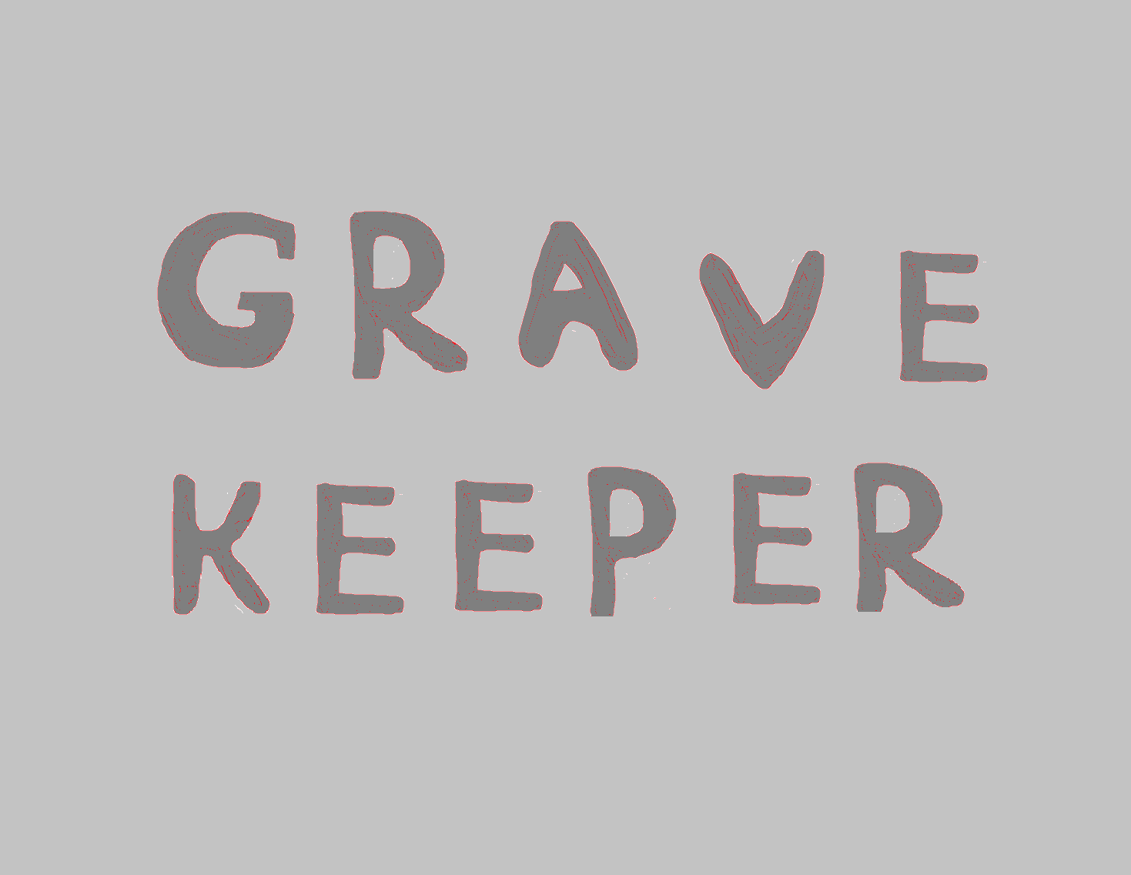

***‘Don’t let these skeletons get under your skin’*** - Aristotle

This page: Table of Contents and Team Member Listing

|  |  |  |
| --- | --- | --- |
| Table of Contents  [1 Game Overview](https://n-xovwktmtjsnaxyc2mwes2xu7pohqedmdm6zjw5q-2lu-script.googleusercontent.com/userCodeAppPanel#)  [2 High Concept](https://n-xovwktmtjsnaxyc2mwes2xu7pohqedmdm6zjw5q-2lu-script.googleusercontent.com/userCodeAppPanel#)  [3 Unique Selling Points](https://n-xovwktmtjsnaxyc2mwes2xu7pohqedmdm6zjw5q-2lu-script.googleusercontent.com/userCodeAppPanel#)  [4 Platform Minimum Requirements](https://n-xovwktmtjsnaxyc2mwes2xu7pohqedmdm6zjw5q-2lu-script.googleusercontent.com/userCodeAppPanel#)  [5 Competitors / Similar Titles](https://n-xovwktmtjsnaxyc2mwes2xu7pohqedmdm6zjw5q-2lu-script.googleusercontent.com/userCodeAppPanel#)  [6 Synopsis](https://n-xovwktmtjsnaxyc2mwes2xu7pohqedmdm6zjw5q-2lu-script.googleusercontent.com/userCodeAppPanel#)  [7 Game Objectives](https://n-xovwktmtjsnaxyc2mwes2xu7pohqedmdm6zjw5q-2lu-script.googleusercontent.com/userCodeAppPanel#)  [8 Game Rules](https://n-xovwktmtjsnaxyc2mwes2xu7pohqedmdm6zjw5q-2lu-script.googleusercontent.com/userCodeAppPanel#)  [9 Game Structure](https://n-xovwktmtjsnaxyc2mwes2xu7pohqedmdm6zjw5q-2lu-script.googleusercontent.com/userCodeAppPanel#)  [10 Game Play](https://n-xovwktmtjsnaxyc2mwes2xu7pohqedmdm6zjw5q-2lu-script.googleusercontent.com/userCodeAppPanel#)  [10.1 Game Controls](https://n-xovwktmtjsnaxyc2mwes2xu7pohqedmdm6zjw5q-2lu-script.googleusercontent.com/userCodeAppPanel#)  [10.2 Game Camera](https://n-xovwktmtjsnaxyc2mwes2xu7pohqedmdm6zjw5q-2lu-script.googleusercontent.com/userCodeAppPanel#)  [10.2.1 HUD](https://n-xovwktmtjsnaxyc2mwes2xu7pohqedmdm6zjw5q-2lu-script.googleusercontent.com/userCodeAppPanel#)  [10.2.2 Maps](https://n-xovwktmtjsnaxyc2mwes2xu7pohqedmdm6zjw5q-2lu-script.googleusercontent.com/userCodeAppPanel#)  [11 Players](https://n-xovwktmtjsnaxyc2mwes2xu7pohqedmdm6zjw5q-2lu-script.googleusercontent.com/userCodeAppPanel#)  [11.1 Characters](https://n-xovwktmtjsnaxyc2mwes2xu7pohqedmdm6zjw5q-2lu-script.googleusercontent.com/userCodeAppPanel#)  [11.2 Metrics](https://n-xovwktmtjsnaxyc2mwes2xu7pohqedmdm6zjw5q-2lu-script.googleusercontent.com/userCodeAppPanel#)  [11.3 States](https://n-xovwktmtjsnaxyc2mwes2xu7pohqedmdm6zjw5q-2lu-script.googleusercontent.com/userCodeAppPanel#)  [11.4 Weapons](https://n-xovwktmtjsnaxyc2mwes2xu7pohqedmdm6zjw5q-2lu-script.googleusercontent.com/userCodeAppPanel#)  [12 Player Line-up](https://n-xovwktmtjsnaxyc2mwes2xu7pohqedmdm6zjw5q-2lu-script.googleusercontent.com/userCodeAppPanel#)  [13 NPC](https://n-xovwktmtjsnaxyc2mwes2xu7pohqedmdm6zjw5q-2lu-script.googleusercontent.com/userCodeAppPanel#)  [13.1 Enemies](https://n-xovwktmtjsnaxyc2mwes2xu7pohqedmdm6zjw5q-2lu-script.googleusercontent.com/userCodeAppPanel#)  [13.1.1 Enemy States](https://n-xovwktmtjsnaxyc2mwes2xu7pohqedmdm6zjw5q-2lu-script.googleusercontent.com/userCodeAppPanel#)  [13.1.2 Enemy Spawn Points](https://n-xovwktmtjsnaxyc2mwes2xu7pohqedmdm6zjw5q-2lu-script.googleusercontent.com/userCodeAppPanel#)  [13.2 Allies / Companions](https://n-xovwktmtjsnaxyc2mwes2xu7pohqedmdm6zjw5q-2lu-script.googleusercontent.com/userCodeAppPanel#)  [13.2.1 Ally States](https://n-xovwktmtjsnaxyc2mwes2xu7pohqedmdm6zjw5q-2lu-script.googleusercontent.com/userCodeAppPanel#)  [13.2.2 Ally Spawn Points](https://n-xovwktmtjsnaxyc2mwes2xu7pohqedmdm6zjw5q-2lu-script.googleusercontent.com/userCodeAppPanel#)  [14 Art](https://n-xovwktmtjsnaxyc2mwes2xu7pohqedmdm6zjw5q-2lu-script.googleusercontent.com/userCodeAppPanel#)  [14.1 Setting](https://n-xovwktmtjsnaxyc2mwes2xu7pohqedmdm6zjw5q-2lu-script.googleusercontent.com/userCodeAppPanel#)  [14.2 Level Design](https://n-xovwktmtjsnaxyc2mwes2xu7pohqedmdm6zjw5q-2lu-script.googleusercontent.com/userCodeAppPanel#)  [14.3 Audio](https://n-xovwktmtjsnaxyc2mwes2xu7pohqedmdm6zjw5q-2lu-script.googleusercontent.com/userCodeAppPanel#)  [15 Procedurally Generated Content](https://n-xovwktmtjsnaxyc2mwes2xu7pohqedmdm6zjw5q-2lu-script.googleusercontent.com/userCodeAppPanel#)  [15.1 Environment](https://n-xovwktmtjsnaxyc2mwes2xu7pohqedmdm6zjw5q-2lu-script.googleusercontent.com/userCodeAppPanel#)  [15.2 Levels](https://n-xovwktmtjsnaxyc2mwes2xu7pohqedmdm6zjw5q-2lu-script.googleusercontent.com/userCodeAppPanel#)  [15.3 Artificial Intelligence NPC](https://n-xovwktmtjsnaxyc2mwes2xu7pohqedmdm6zjw5q-2lu-script.googleusercontent.com/userCodeAppPanel#)  [15.4 Visual Arts](https://n-xovwktmtjsnaxyc2mwes2xu7pohqedmdm6zjw5q-2lu-script.googleusercontent.com/userCodeAppPanel#)  [15.5 Audio](https://n-xovwktmtjsnaxyc2mwes2xu7pohqedmdm6zjw5q-2lu-script.googleusercontent.com/userCodeAppPanel#)  [15.6 Minimum Viable Product (MPV)](https://n-xovwktmtjsnaxyc2mwes2xu7pohqedmdm6zjw5q-2lu-script.googleusercontent.com/userCodeAppPanel#)  [16 Wish List](https://n-xovwktmtjsnaxyc2mwes2xu7pohqedmdm6zjw5q-2lu-script.googleusercontent.com/userCodeAppPanel#)  [1](https://n-xovwktmtjsnaxyc2mwes2xu7pohqedmdm6zjw5q-2lu-script.googleusercontent.com/userCodeAppPanel#)7 Bibliography   |  | | --- | |  | | Game Development Team Members    PRODUCER  David Oyos    PRODUCTION MANAGER  Sam Saenz    PRODUCTION COORDINATOR  Riley Mollon  GAME DESIGNERS  Riley Mollon, Austin Eccher, Sam Saenz, David Oyos  SYSTEMS/IT COORDINATOR  David Oyos  PROGRAMMERS  Riley Mollon, Austin Eccher, Sam Saenz, David Oyos  TECHNICAL ARTISTS  Austin Eccher  AUDIO ENGINEERS  Riley Mollon  UX TESTERS  Riley Mollon, Austin Eccher, Sam Saenz, David Oyos |

|  |
| --- |
|  |

# 1 Game Overview

Title: Gravekeeper

Platform: PC Standalone

Genre: Wave Survival First-Person Shooter

Rating: (10+) ESRB

Target: Casual gamer (aging from 12 - 30)

Serious games

Release date: December 2020

Publisher: Big Metal Fans

Description: It is a first-person shooter with endless waves of enemies. The longer the game goes on, the harder it becomes. The player will be able to purchase upgrades and ammo that will help them get further. Ammo will be available during the game, while stat upgrades are available between games.

Inventory System: Guns/Ammo

Gamification: Killing enemies scores points, player decides how to spend them

Questing: Optional challenges to use certain guns for kills and reward credits

# 2 High Concept

This game is based on endless survival games, where enemies will constantly spawn in waves until you die. There is progression in the enemies, with their health and numbers increasing with each consecutive wave. To balance this there is progression in the strength of the player as well, through upgrades like damage, reload speed, and running speed.

# 3 Unique Selling Points

Gradual progression of both difficulty and player strength

4 distinct weapons with different play styles

Immersive audio experience through music and sound effects

# 4 Platform Minimum Requirements

Must be able to run a Unity developed application

Hardware capable of light model and terrain rendering

This game was developed entirely on Windows machines

# 5 Competitors / Similar Titles

* Call of Duty Zombies
* TF2 Mann vs Machine
* Counter-Strike

# 6 Synopsis

Grave Keeper is an FPS survival game where you take on hordes of skeletons to stay alive. Upgrade your weapons, and stock up on ammo in order to stand a chance of seeing the sunrise.

# 7 Game Objectives

Survive as long as possible. Kill all enemies in the wave to proceed.

Purchase ammunition to be able to continue killing enemies in that run.

Purchase permanent character upgrades to make it farther each consecutive

playthrough.

# 8 Game Rules

The game level is a closed environment where the player is attacked by continuous waves of skeleton enemies. The player must figure out how to maneuver through the level and kill the enemies without dying themselves. Every time the player completes a wave, the next wave will be more difficult for them to survive. The only way to get more ammunition is by interacting with the ammo shop which is roughly central in the map, it will open a shop menu which does not pause the game, so the player must act quickly before the enemies catch up. Once the player dies, unspent credits will be added to their overall total and can be spent on permanent upgrades that will help the player in future runs.

# 9 Game Structure

Wave based gameplay, start with no upgrades.

Purchase ammo mid-game to help you go further.

After the game, purchase permanent upgrades that will help you on all future runs

# 10 Game Play

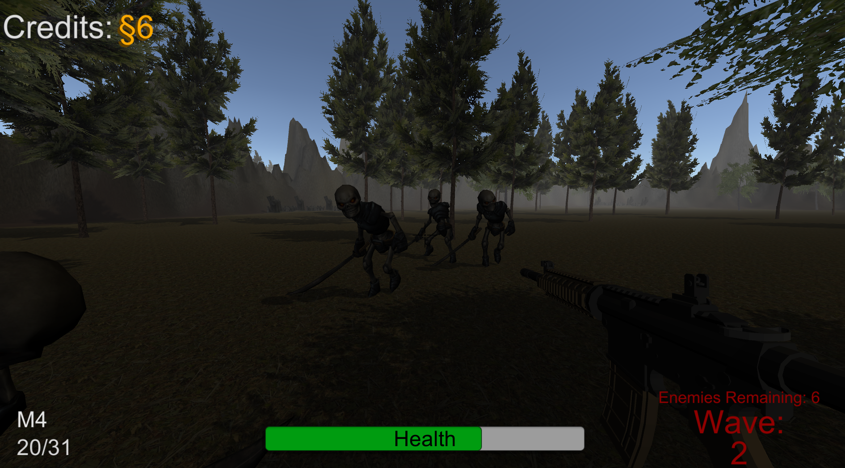

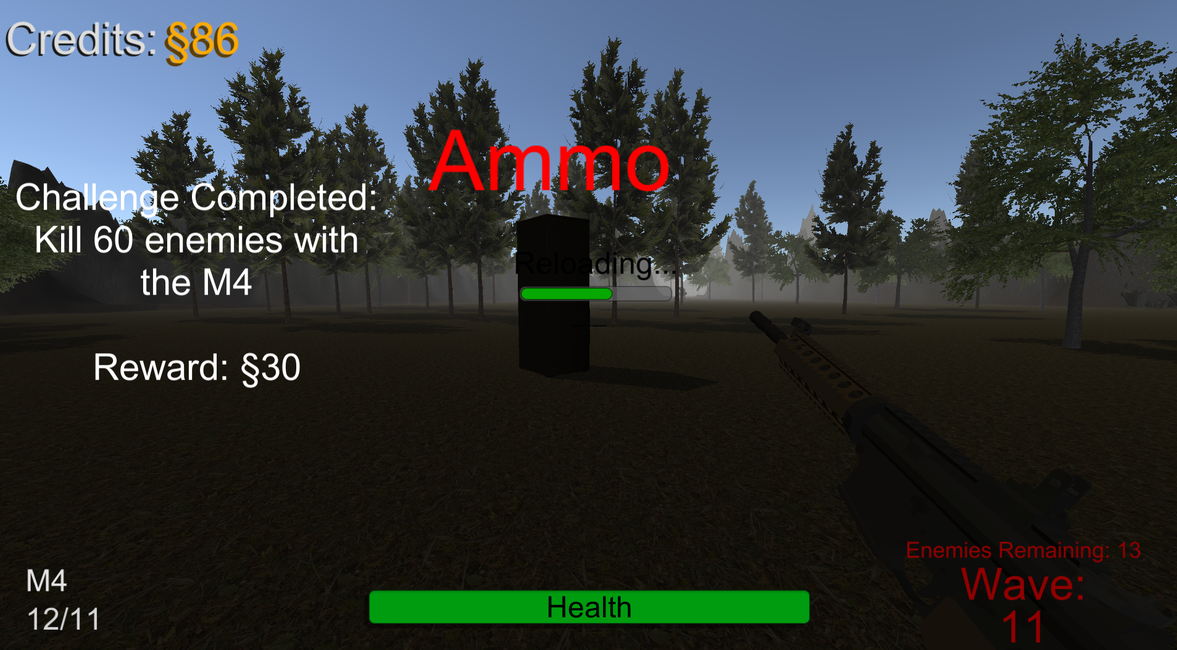

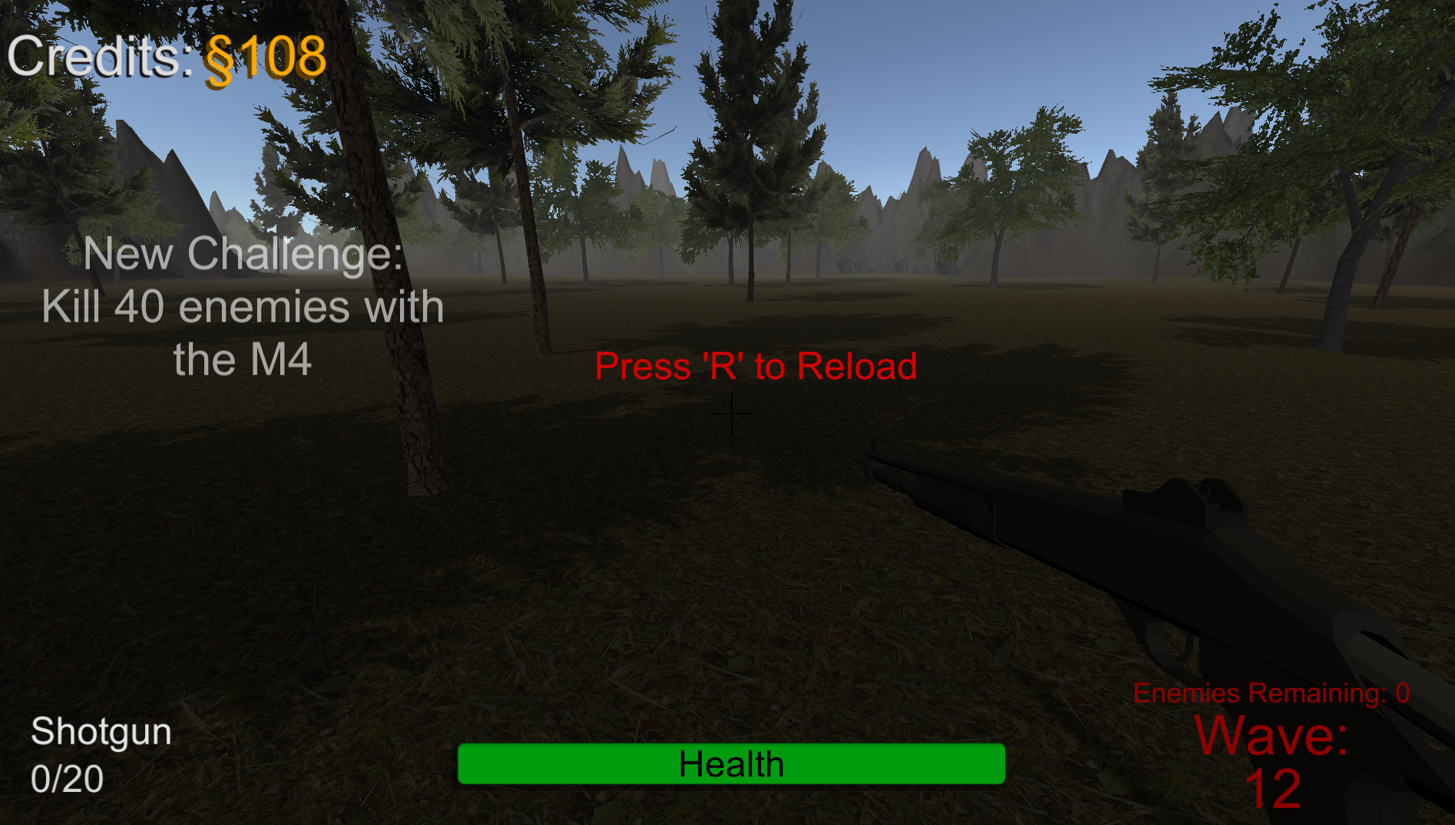

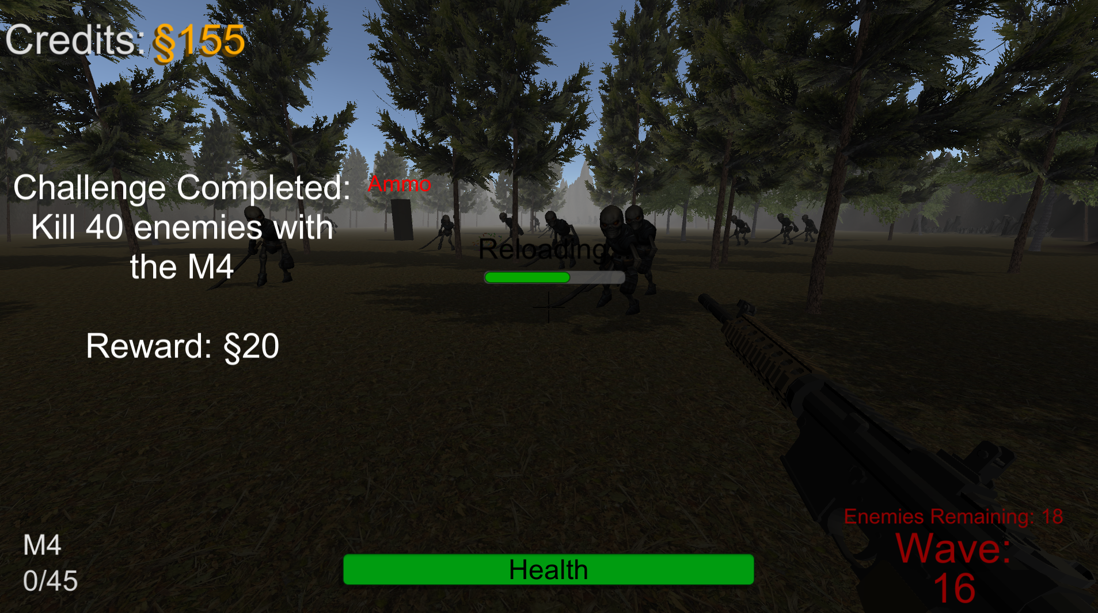

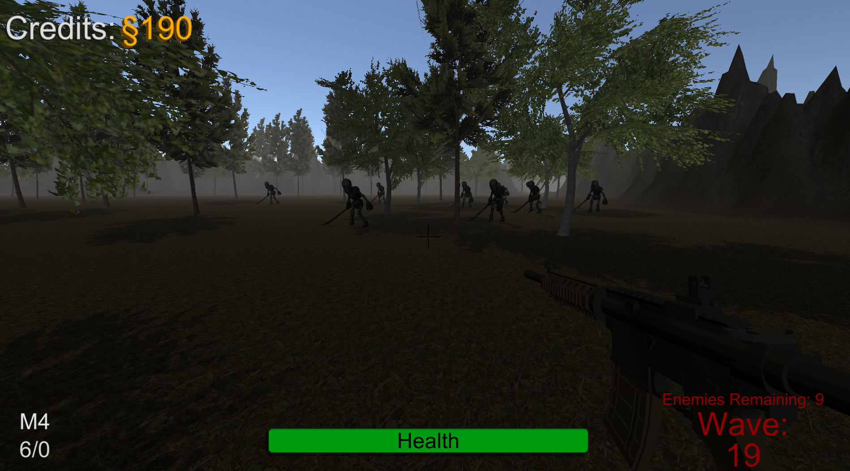

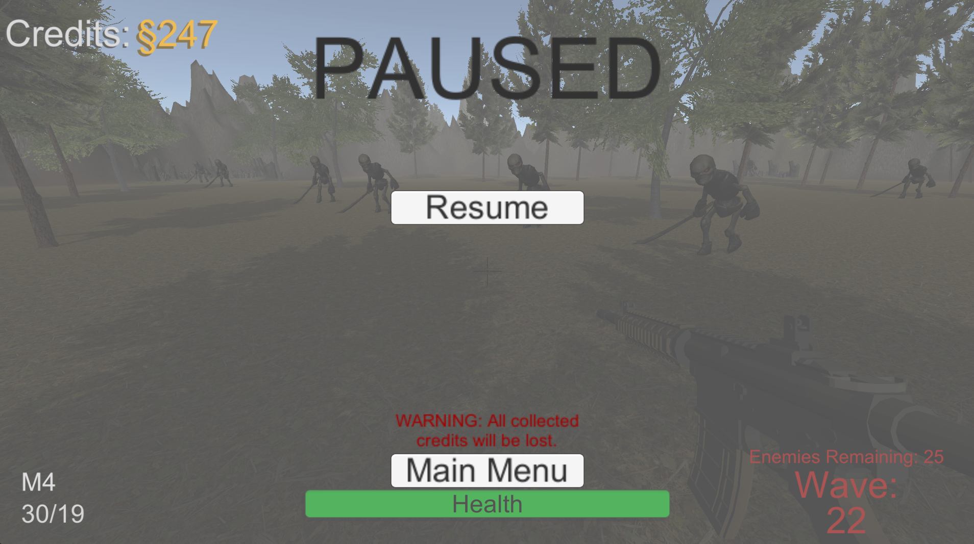

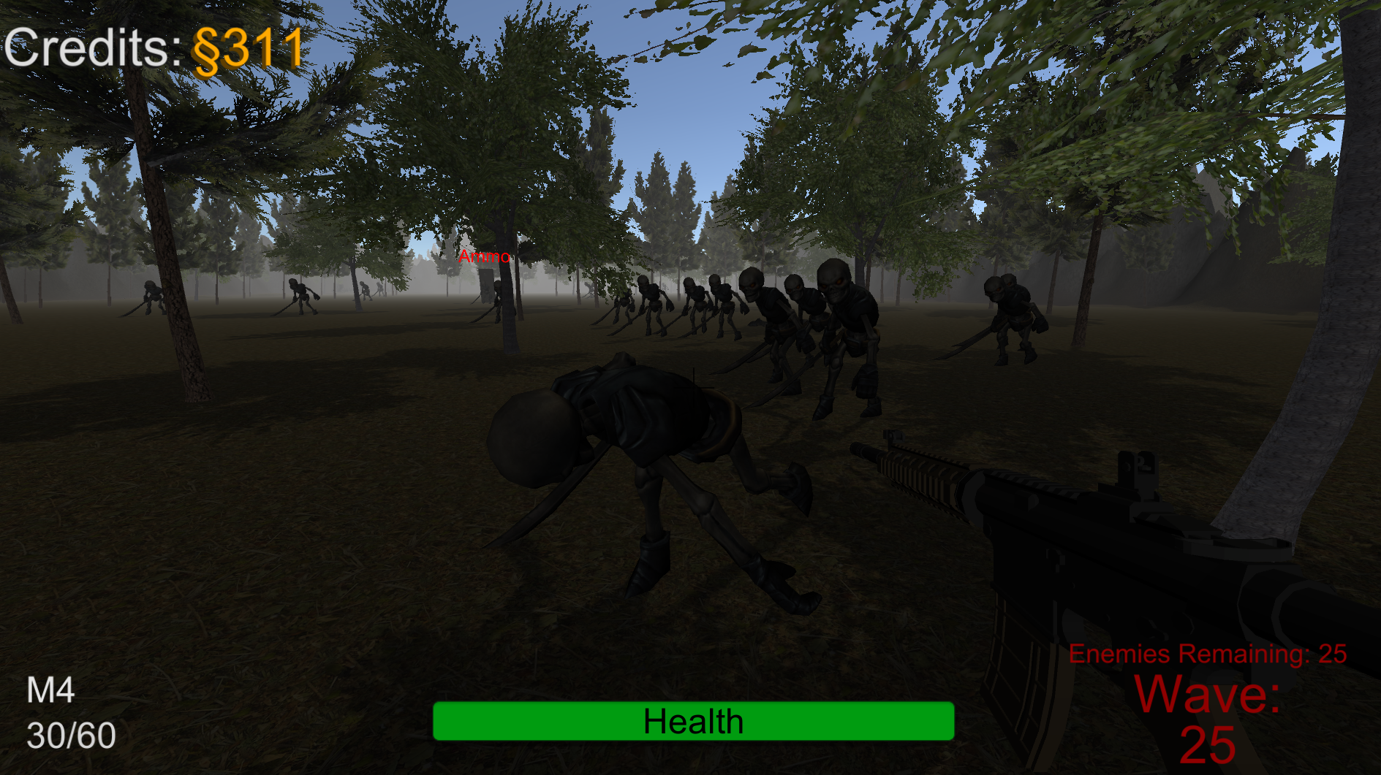

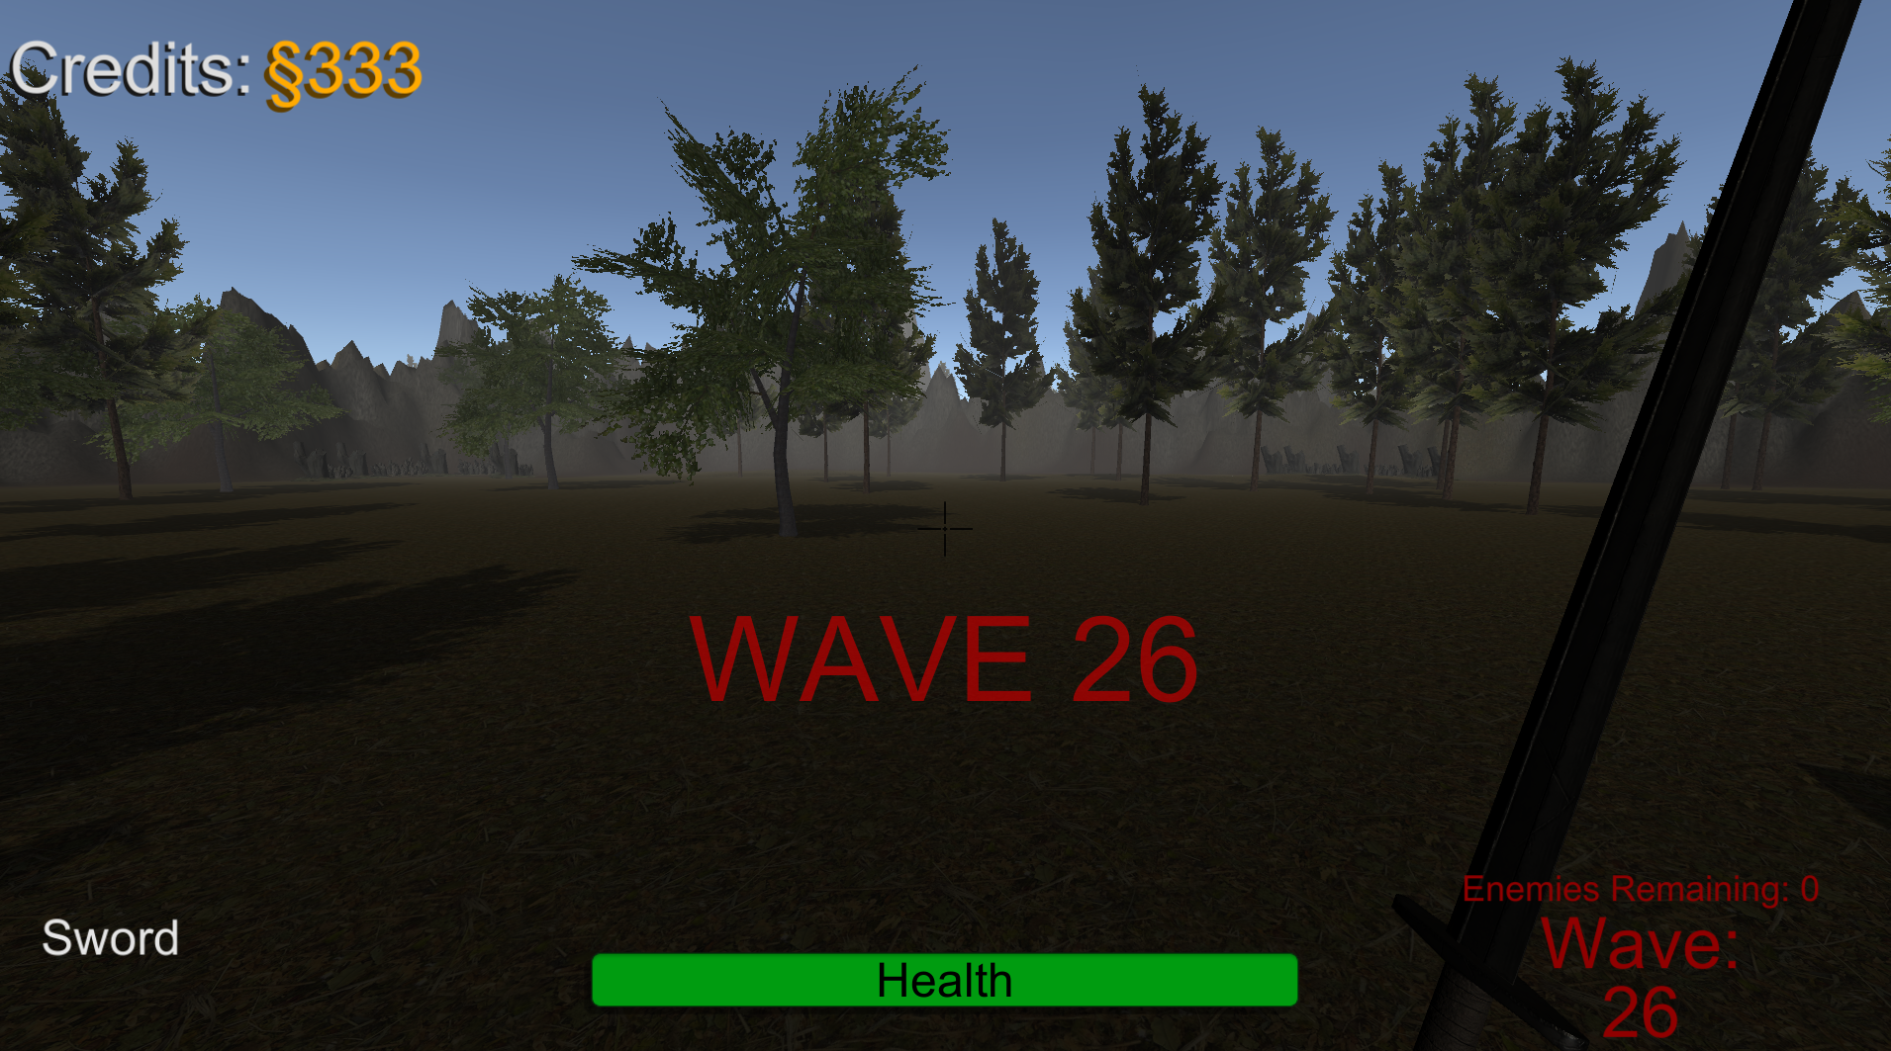

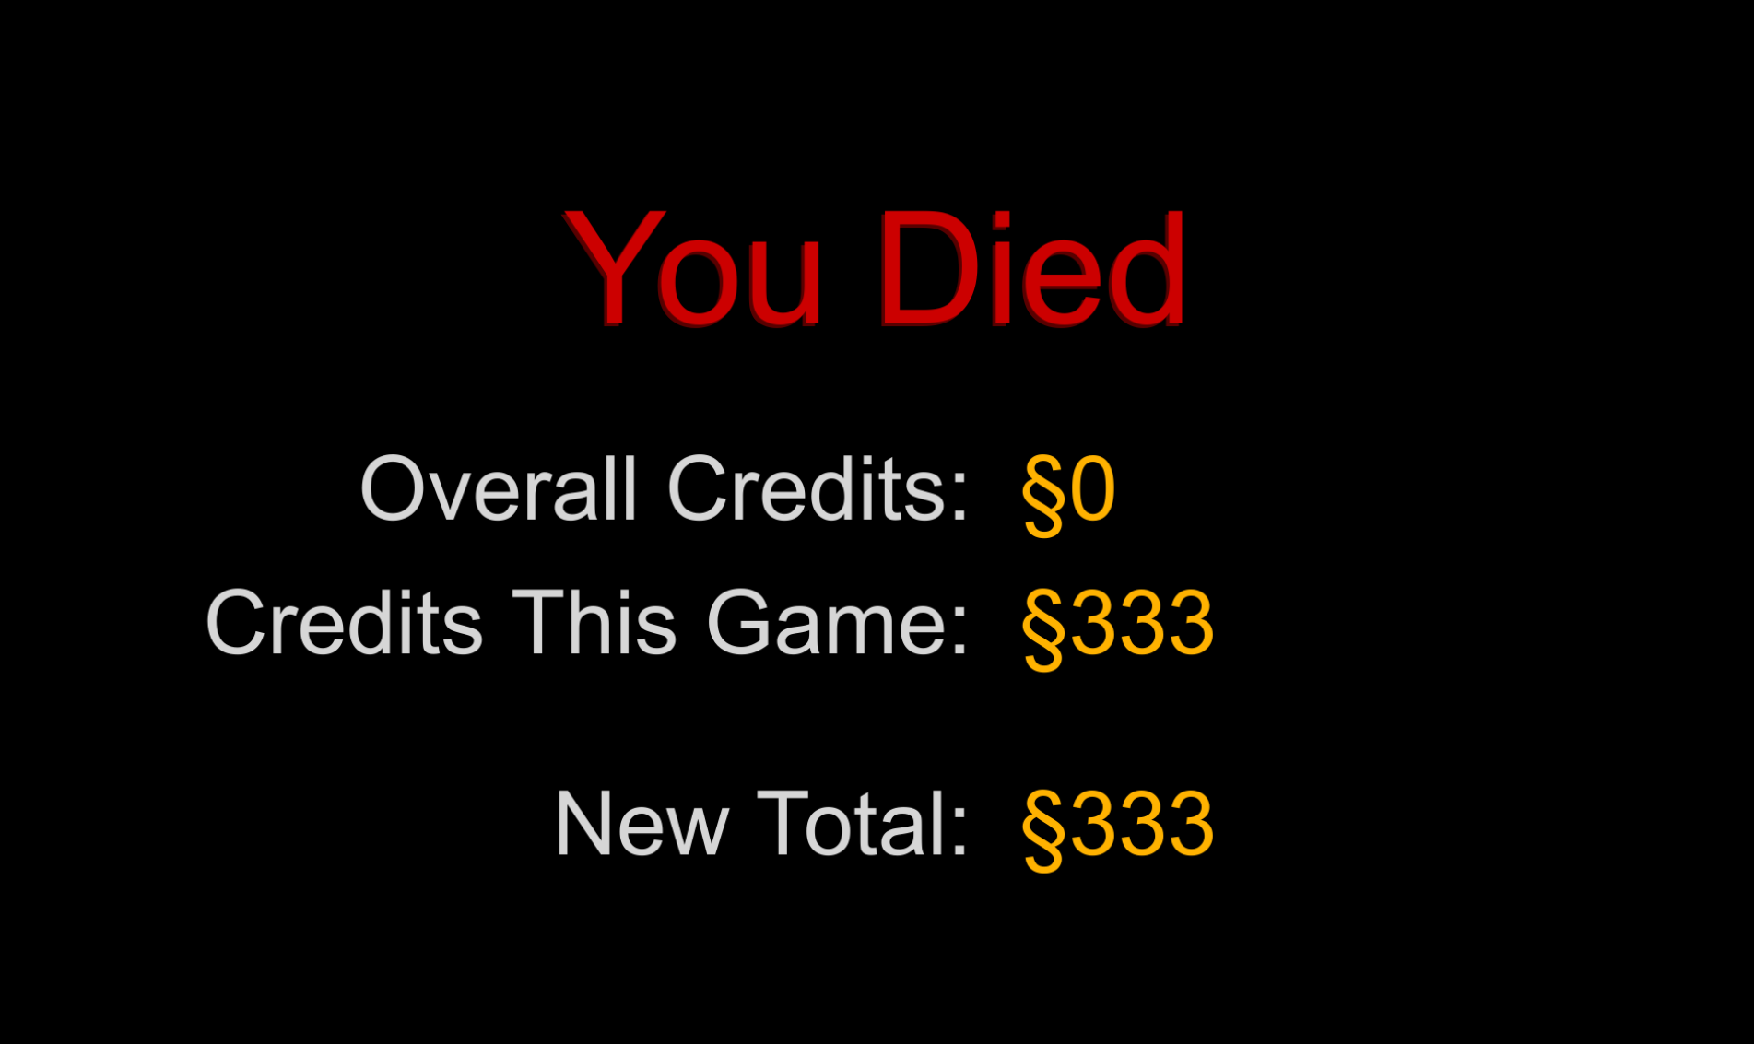

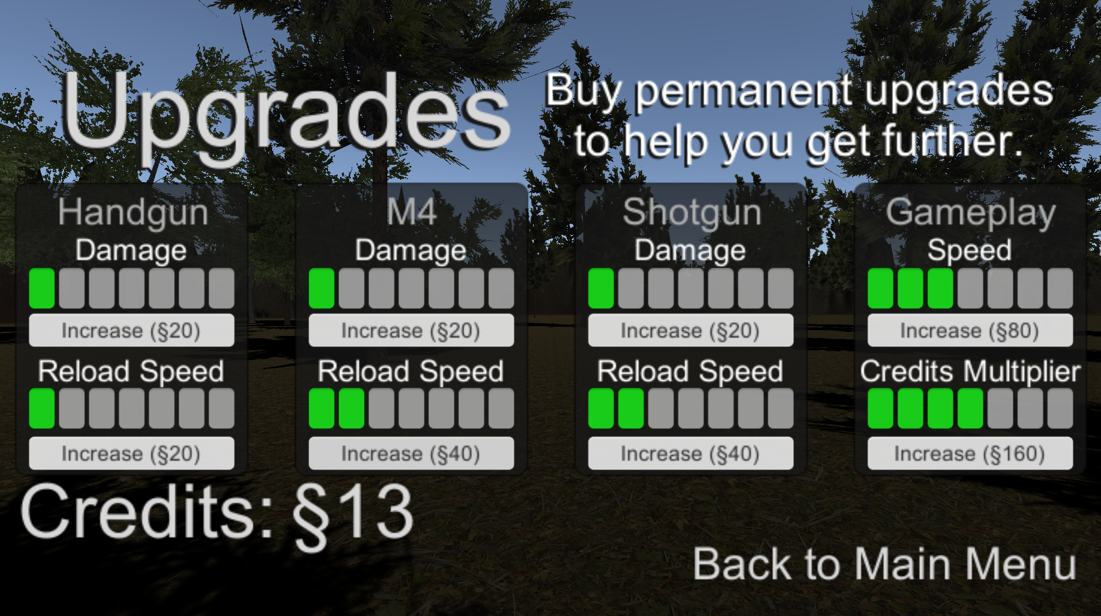

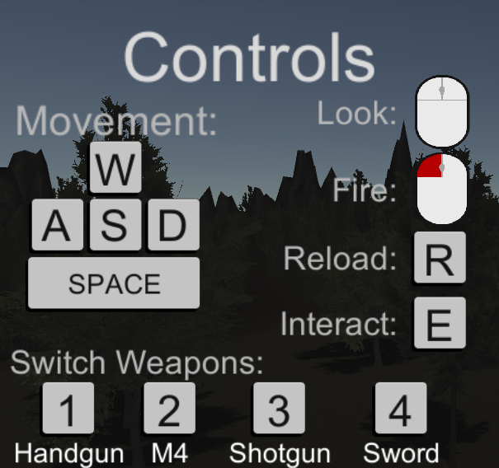

## 10.1 Game Controls

WASD to move

Esc to pause

E to open shop at locker

Mouse to aim

Mouse Button 1 to shoot

R to reload

Numbers 1-4 to switch weapons

## 10.2 Game Camera

First person camera attached to the player position at head level. While in the game scene, the camera never moves from this position.

### 10.2.1 HUD

Simple HUD with health, ammo, credits, wave number, and amount of enemies remaining.

### 10.2.2 Maps

One large open map, a forested area with mountainous edges.

# 11 Players

## 11.1 Characters

The character is meant to be a representation of the player. For this reason we decided not to have a character model in place. There are no other characters that are featured in the game, as the skeletons are nameless enemies and thus are not considered characters.

## 11.2 Metrics

Health, Ammo, Money, and two types of credits; one that persists between games but is only usable to buy permanent upgrades, and one that is within the current run and can be used to buy ammunition.

## 11.3 States

If the player takes three consecutive hits without healing, they will die which disables all control and eventually returns them to the main menu. Otherwise, their state is alive and they can move freely around the map and use their weapons unless they are within the ammo shop or pause menu.

## 11.4 Weapons

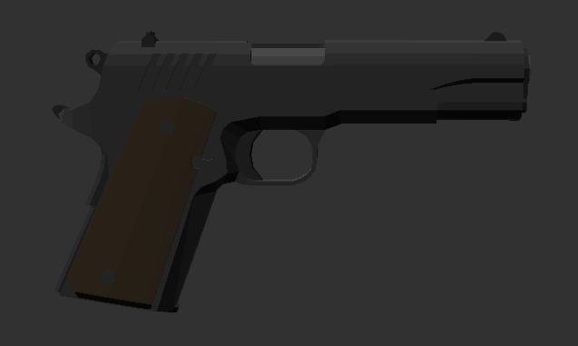

Handgun

# Magazine Capacity: 8

Reserve Capacity: 80

Damage: 4

Reload Time: 0.8s

Bullet Speed: 50

Ammo Price: §5

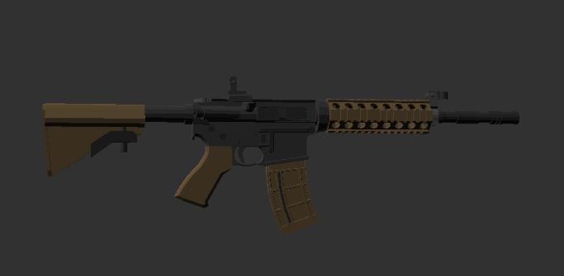

M4

# Magazine Capacity: 30

Reserve Capacity: 90

Damage: 3

Reload Time: 2.7s

Bullet Speed: 70

Ammo Price: §6

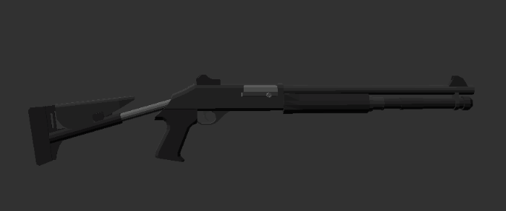

Shotgun

# Magazine Capacity: 6

Reserve Capacity: 20

Damage: 2 x 10

Reload Time: 4.8s

Bullet Speed: 60

Ammo Price: §7

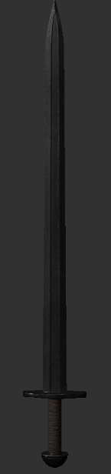

Sword

Damage: 8

# 12 Player Line-up

There is only a single nameless player. The game is first-person only, so the player has no visible appearance within the game.

# 13 NPC

The only NPCs are the skeletons which attack you on each wave.

## 13.1 Enemies

Enemies are skeletons with swords. If they get close, they will begin to swing at you. This gives you some time to move out of the way of their swing

### 13.1.1 Enemy States

Enemies are always moving towards the player after spawning. When their health reaches zero, they fall to the ground dead and all colliders are removed. After a couple seconds their body explodes and they are permanently gone.

### 13.1.2 Enemy Spawn Points

Enemies spawn from specific locations placed around the map. In each wave, every attempt to spawn an enemy will choose a random location to place it. This results in a fairly even spread of enemies on each spawn location.

## 13.2 Allies / Companions

You are alone in the world. There are no allies to back you up.

### 13.2.1 Ally States

N/A (See above)

### 13.2.2 Ally Spawn Points

N/A (See above)

# 14 Art

The level design and some sprite work was done custom for this game. All models were downloaded for free from the Unity asset store.

## 14.1 Setting

Game setting is outdoors in a small forest area. There are trees that populate the area surrounded by mountains. The game is set in the evening as to give an ominous/ horror-game feeling as the player plays the game.

Enemies spawn from an area which contains a ring of stumps, which stands out from the rest of the game world.

## 14.2 Level Design

The level was created with a combination of terrain shaping and model asset insertion.

## 14.3 Audio

Music in every scene

Sounds effects when shooting weapons

Sounds effects when counting credits

Sound effects when enemies die

# 15 Procedurally Generated Content

The game contains no procedurally generated content

## 15.1 Environment

The environment is not procedurally generated

## 15.2 Levels

Waves of enemies that get progressively harder acts as the level system, their health and numbers increase in a uniform manner, where:

Amount of enemies = wave # + 4

Enemy health = (sqrt(wavenum) * 2.5) + 10

## 15.3 Artificial Intelligence NPC

* Enemies run towards player
* Enemies avoid obstacles such as trees and other enemies

## 15.4 Visual Arts

Most visual arts consists of models and textures downloaded from the asset store

## 15.5 Audio

Sound effects for many actions as well as ambient music that sets a somewhat ominous tone while the player is in game.

## 15.6 Minimum Viable Product (MPV)

Character movement

Map

At least one weapon

One enemy

# 16 Wish List

Multiple maps

Multiple enemies

Bigger map with more complex features (buildings etc)

Buying weapons and having a limited number rather than starting with and always

having all of them

More weapons

More ingame upgrades (something like perk machines/pack a punch from Call of Duty

zombies?)

# 17 Bibliography

**Scripts:**

Eccher, Austin. & Mollon, Riley. Enemy.cs. 2020. C# Script File.

Saenz, Sam. PauseMenu.cs. 2020. C# Script File

Mollon, Riley. PersistantData.cs. 2020. C# Script File

Mollon, Riley, Saenz, Sam & Eccher, Austin. Player.cs. 2020. C# Script File.

Saenz, Sam. Shop.cs. 2020. C# Script File.

Eccher, Austin. Spawner.cs. 2020. C# Script File.

Oyos, David. UpgradesText.cs. 2020. C# Script File.

Mollon, Riley. CreditsManager.cs. 2020. C# Script File.

Mollon, Riley. MainMenuButton.cs. 2020. C# Script File.

Mollon, Riley. MainMenuController.cs. 2020. C# Script File.

Mollon, Riley. UpgradesData.cs. 2020. C# Script File.

Mollon, Riley. UpgradesHover.cs. 2020. C# Script File.

Mollon, Riley. WaveManager.cs. 2020. C# Script File.

Mollon, Riley. WaveSpawner.cs. 2020. C# Script File.

Mollon, Riley & Eccher, Austin. Bullet.cs. 2020. C# Script File.

Mollon, Riley & Saenz, Sam. Handgun.cs. 2020. C# Script File.

Mollon, Riley & Saenz, Sam. MachineGun.cs. 2020. C# Script File.

Mollon, Riley & Saenz, Sam. Shotgun.cs. 2020. C# Script File.

Mollon, Riley & Saenz, Sam. Sword.cs. 2020. C# Script File.

**Scenes:**

Mollon, Riley. (12/10/20). MainMenu.unity. CS583F2020 Project 3.

Mollon, Riley. (12/09/20). Credits.unity. CS583F2020 Project 3.

Oyos, David, Saenz, Sam, Eccher, Austin & Mollon, Riley (12/10/20). Game.unity. CS583F2020

Project 3.

**Models/Packages:**

Mercuzot, Simon. Low Poly Weapons VOL.1. Unity Asset Store. Aug. 14, 2019. Retrieved 2020.

https://assetstore.unity.com/packages/3d/props/guns/low-poly-weapons-vol-1-151980

Osmann. Melee Weapons Pack [Swords - Axes]. Sep. 24, 2019. Retrieved 2020.

<https://assetstore.unity.com/packages/3d/props/weapons/melee-weapons-pack-swords->

xes-121237

Teamjoker. Fantasy Monster - Skeleton. Aug. 18, 2015. Retrieved 2020.

<https://assetstore.unity.com/packages/3d/characters/humanoids/fantasy-monster-skelet>

n-35635

VIS Games. Locker. Mar. 13, 2018. Retrieved 2020.

<https://assetstore.unity.com/packages/3d/props/locker-56405>

STmodels. Photogrammetry stump. Feb. 22, 2019. Retrieved 2020.

<https://assetstore.unity.com/packages/3d/environments/photogrammetry-stump-140444>

A dog’s life software. Outdoor Ground Textures. Sep. 26, 2016. Retrieved 2020.

<https://assetstore.unity.com/packages/2d/textures-materials/floors/outdoor-ground-textu>

es-12555

Laxer. Mobile Tree Package. Feb. 5, 2016. Retrieved 2020.

<https://assetstore.unity.com/packages/3d/vegetation/trees/mobile-tree-package-18866>

**Music:**

MacLeod, Kevin. (11/18/2020). Ether Vox. Digital.

<https://incompetech.filmmusic.io/song/7014-ether-vox>

Usage: Main Menu

The artist has also asked for this exact text to be included:

**Ether Vox by Kevin MacLeod**

**Link:** [**https://incompetech.filmmusic.io/song/7014-ether-vox**](https://incompetech.filmmusic.io/song/7014-ether-vox)

**License:** [**http://creativecommons.org/licenses/by/4.0/**](http://creativecommons.org/licenses/by/4.0/)

MacLeod, Kevin. (10/08/2020). Scp x1x (Gateway to Hell). Digital.

<https://incompetech.filmmusic.io/song/6732-scp-x1x-gateway-to-hell->

Usage: Ingame

The artist has also asked for this exact text to be included:

**Scp x1x (Gateway to Hell) by Kevin MacLeod**

**Link:** [**https://incompetech.filmmusic.io/song/6732-scp-x1x-gateway-to-hell-**](https://incompetech.filmmusic.io/song/6732-scp-x1x-gateway-to-hell-)

**License:** [**http://creativecommons.org/licenses/by/4.0/**](http://creativecommons.org/licenses/by/4.0/)

MacLeod, Kevin. (10/08/2020). Scp X3x (I Am Not OK). Digital.

<https://incompetech.filmmusic.io/song/6733-scp-x3x-i-am-not-ok->

Usage: Credits

The artist has also asked for this exact text to be included:

**Scp X3x (I Am Not OK) by Kevin MacLeod**

**Link:** [**https://incompetech.filmmusic.io/song/6733-scp-x3x-i-am-not-ok-**](https://incompetech.filmmusic.io/song/6733-scp-x3x-i-am-not-ok-)

**License:** [**http://creativecommons.org/licenses/by/4.0/**](http://creativecommons.org/licenses/by/4.0/)

**SFX:**

Nagwense. (11/4/17). Gunshot. Digital. Retrieved 2020 from

<https://freesound.org/people/Nagwense/sounds/407662/>

nioczkus. (06/28/17). 1911 Reload. Digital. Retrieved 2020 from

<https://freesound.org/people/nioczkus/sounds/396331/>

FilmmakersManual, (06/16/20). Gun Dry Firing (7). Digital. Retrieved 2020 from

<https://freesound.org/people/FilmmakersManual/sounds/522414/>

ninebilly. (06/02/20). ak 47 - single shot.mp3. Digital. Retrieved 2020 from

<https://freesound.org/people/ninebilly/sounds/520934/>

kennysvoice (08/10/16). AK47 SFX.mp3. Digital. Retrieved 2020 from

<https://freesound.org/people/kennysvoice/sounds/351778/>

Marregheriti. (03/06/15). Shotgun.wav. Digital. Retrieved 2020 from

<https://freesound.org/people/Marregheriti/sounds/266105/>

lensflare8642. (02/06/12). shotgun sounds. Digital. Retrieved 2020 from

<https://freesound.org/people/lensflare8642/sounds/145209/>

deleted_user_6479820. (02/11/17). Sword Swipes. Digital. Retrieved 2020 from

<https://freesound.org/people/deleted_user_6479820/sounds/380488/>

deleted_user_96253. (08/01/16). Cha Ching.wav. Digital. Retrieved 2020 from

<https://freesound.org/people/deleted_user_96253/sounds/351304/>

swuing. (08/11/07). footstep-grass.wav. Digital. Retrieved 2020 from

<https://freesound.org/people/swuing/sounds/38874/>

FilmmakersManual. (06/16/20) Bullet - Hit Body (9). Digital. Retrieved 2020 from

<https://freesound.org/people/FilmmakersManual/sounds/522504/>

bananplyte. (12/10/18). Bullets hitting Gore. Digital. Retrieved 2020 from

<https://freesound.org/people/bananplyte/sounds/452155/>

**Sprites:**

Mollon, Riley. (12/04/20). Crosshair.png. CS583F2020 Project 3.

Mollon, Riley. (12/08/20). Mouse.png. CS583F2020 Project 3.

Mollon, Riley. (12/08/20). MouseLMB.png. CS583F2020 Project 3.

Mollon, Riley. (12/10/20). WeaponShop.png. CS583F2020 Project 3.